Prakhar Saxena

Professor Bhupesh Shetty

INFO 250 – 001

December 1, 2020

Project 2 – Final Project

I have published my tableau workbook on Tableau’s public server. There are a lot of sheets there which may or may not be interesting to you, but I added them there because they helped me create the Dashboards.

https://public.tableau.com/profile/prakhar.saxena7174#!/vizhome/Project2Revised/Dashboard2

**Temperature and Crime Vs Months (split by UCR part categorisation)**

Before

After

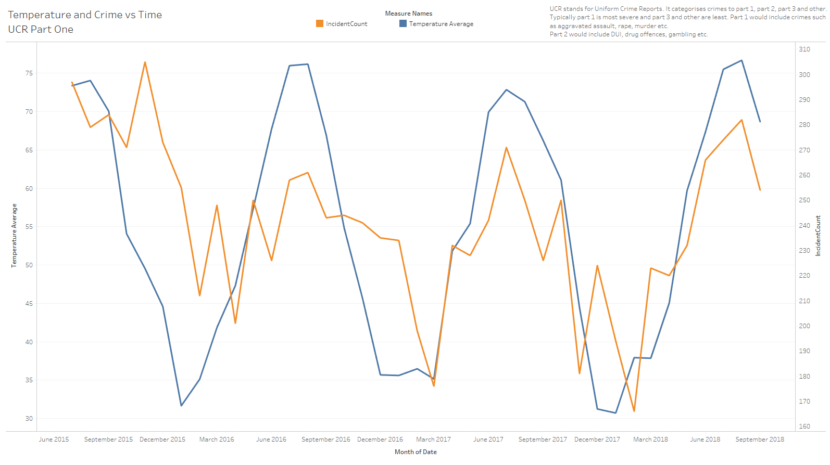

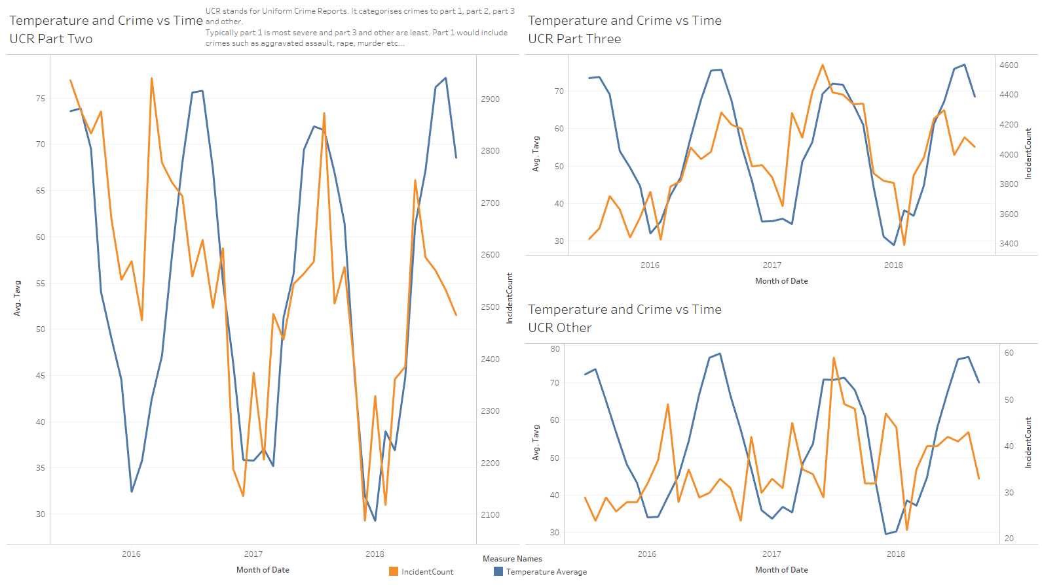

I added a textbox on both the dashboards that concisely describes what UCR categorisation is. I believe this was recommended because it may or may not be common knowledge.

**Top 20 Offenses by Types**

Before

After

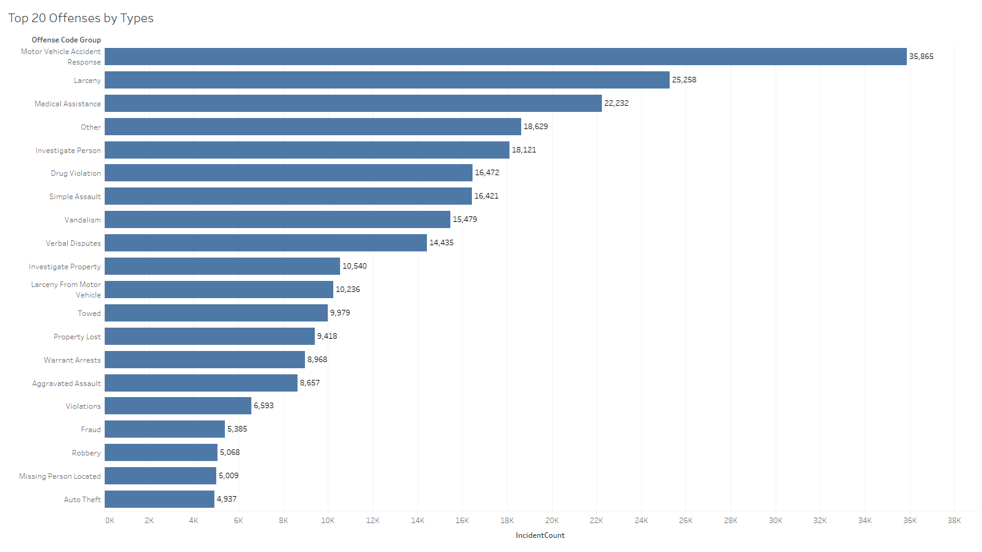

The change I made in this graph is that I added label of the incident count to the bars. This way the viewers can see the number at the first glance itself.

**Shooting**

Before

After

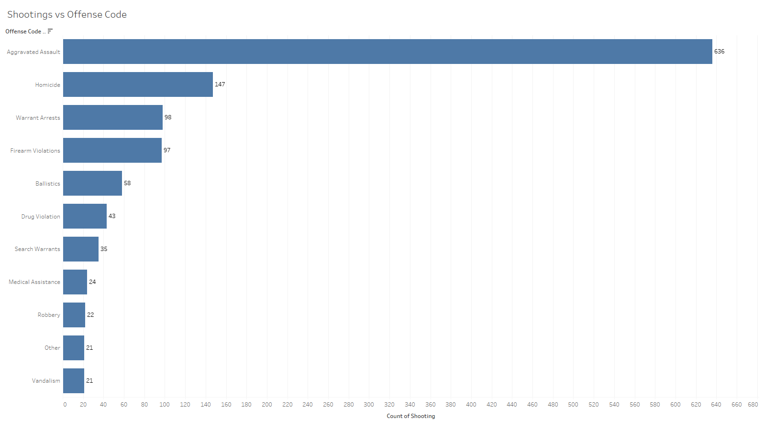

The change I made in this graph is the similar to the last one. I added label of shooting count to the bars, so that viewers can see the number at the first glance itself.

**what are the most and least useful aspect of this course do you see?**

I found this course useful because it taught me the practicality of data science. Fitting a Machine Learning model though important, but at the end of the day, one needs proper effective visualisations to show results. A successful data scientist is not just one who comes up with the best model, but also the one that can convey their message across well.

Cheers